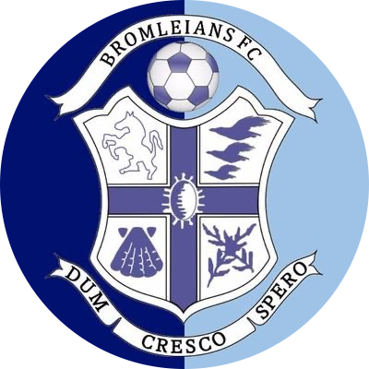

**Bromleians Football Club**

COMPLAINTS & DISCIPLINARY PROCEDURE

|  |  |
| --- | --- |
| **Date:** | 05th February 2021 |
| **Date to be reviewed:** | 05th February 2022 |
| **Author:** | Club Welfare Officer |
| **Junior Section Committee Sign off Date:** | 1st March 2021 |

**BROMLEIANS FC**

**Complaints & Disciplinary Procedure**

In the event that any member or parent of a member feels that the Bromleians FC’s policies, rules or codes of conduct have been broken, they should follow the procedures set out below.

In the first instance, it is hoped that any issues could be dealt with informally with the matter being raised in the first instance with the member’s coach by the member parent/ complainant at an appropriate time (i.e. not at or during a match or in front of the players). Should the matter not be resolved informally, not be appropriate for informal discussion (in particular should it involve an issue of child welfare), then the matter should be reported to a member of the Clubs Board or Junior Section Committee member.

The report should include:

* Details of what, where and when the incident took place.
* Any witness statements and names.
* Names of any others who have been treated in a similar way.
* Details of any former complaints made about the incident, dates, when and to whom made.
* A preference for a solution to the incident.

The Clubs Board/ Junior Section Committee will consider the issue as presented and decide whether further investigation is necessary or whether a written decision can be reached by simple reference to the Bromleians FC’s policies, rules or codes of conduct. If a written decision can be made without further investigation this will take place within 14 days from the date of receipt of the report.

**Any issue involving child welfare will ALWAYS involve the Child Welfare Officer (“CWO”) and strictly follow the Clubs Safeguarding Policy.**

Should the Clubs Board/ Junior Section Committee determine that any complaint requires further investigation, a formal meeting will be convened. The member parent / complainant and coach may be required to attend together with the CWO and 2 Board/ Junior Section Committee members – the meeting will be minuted. Any such meeting will be confidential and all parties will be asked to speak and further clarification and documentation may be requested. Any such meeting will be conducted politely, with respect and without use of inappropriate language.

The CWO and 2 Board/ Junior Section Committee members will consider and deliver a decision in writing. Such decisions will be in accordance with Bromleians FC’s policies, rules or codes of conduct. The decision may be given immediately or by email within one month of the meeting date.

Bromleians FC have the power to enforce the below sanctions on any person(s) found to have broken Bromleians FC’s policies, rules or codes of conduct:

* Warn as to future conduct
* Suspend from membership
* Remove from membership

The Board/ Junior Section Committee decision is final and only in exceptional circumstances where additional information not previously presented is provided in writing within 14 days will appeals be considered.